|  |  |  |
| --- | --- | --- |
| Containers on AWS | * Docker for Beginners * Introduction to ECS * AutoScaling with ECS | [Docker for Beginners](https://www.youtube.com/watch?v=pg19Z8LL06w)  **Section  18 - (199 - 209)** |
| Decouple Applications | * SQS * SNS | **Section 17 - (183 - 192 )** |

1. You are an AWS cloud engineer tasked with deploying a containerized web application using Amazon ECS with EC2 launch type to handle varying traffic loads.

**Requirements:**

* Deploy web application using ECS with EC2 instances
* Set up an Application Load Balancer to distribute traffic.
* Implement basic EC2 auto-scaling.
* Monitor container health and log application events using CloudWatch.

**Questions:**

* How would you design the ECS cluster with EC2 instances?
* What instance types would you choose and why?- T2.micro
* What monitoring metrics would you setup? – Cloudwatch monitoring Insights
* How would you handle container updates? – In deployment options of service, chose Rolling update

**Sample Docker Image:**

[hello-world - Official Image | Docker Hub](https://hub.docker.com/_/hello-world)

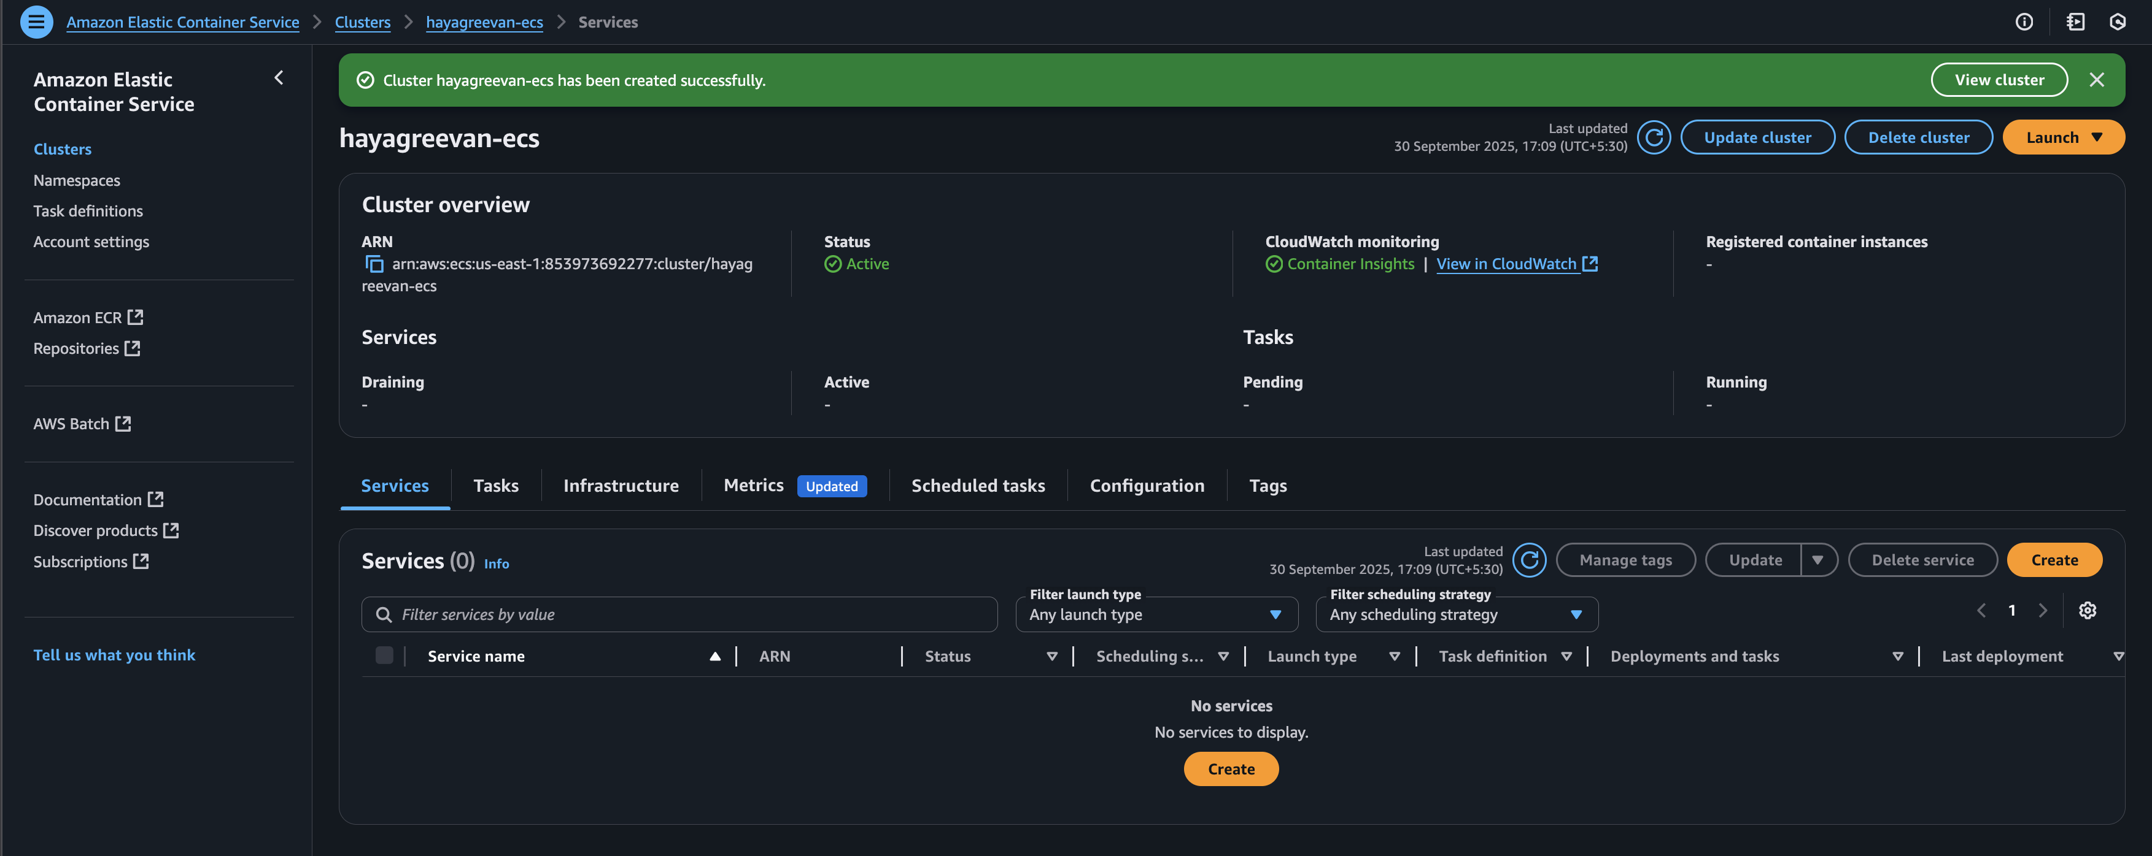

1. You are a cloud engineer tasked in designing a notification system for an e-commerce platform to process and track orders.

**Requirements:**

* Use SNS to send order confirmations to customers.
* Use SQS to process order details in a separate queue.
* Handle failed message delivery
* Monitor queue performance

**Questions:**

* How would you handle message failures? – By configuring Dead letter queue
* What monitoring metrics would you set up? – By setting up CloudWatch

